|  |
| --- |
| **MATHEMATICS DEPARTMENT 2015**  **Year 11 Specialist - Test Number 5**  Trigonometric Identities and Complex Numbers |



**Name: ____SOLUTIONS_______________________ Teacher: DDA**

**Marks: 50**

**Time Allowed: 45 minutes**

**Instructions:** You arepermitted 1 page notes but no calculator.

_________________________________________________________________________

**Part A**

8 multiple-choice questions

1 mark each: 8 marks

Circle the correct answer.

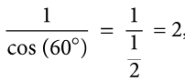1 sec (60°) =

A 2



B 

C 

D 

E 

[1 mark]

2 sin  =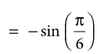

A −2

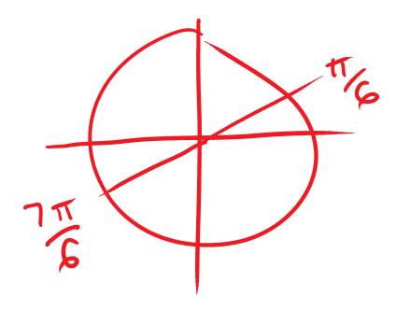B 

C 

D 

E 



[1 mark]

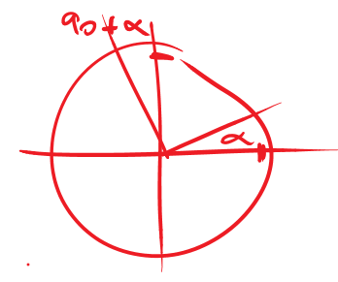3 sin (90° + α) =

A sin (α)

B −sin (α)

C cos (α)



D −cos (α)

E sin (90°)



[1 mark]

4 The graph shown below could have the equation:

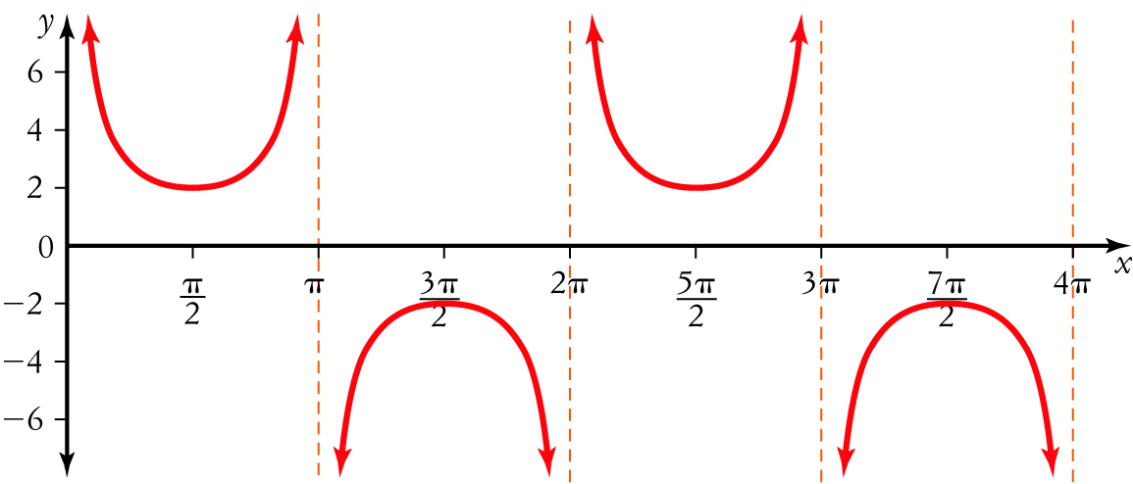

A y = 2 cosec (x)



B y = 2 sec (x − 1)

C y =  cosec (x)

D y =  sin (x)

E y = cosec 

[1 mark]

5 mod =

A 4

B –2

C 

D 2



E 2i

[1 mark]

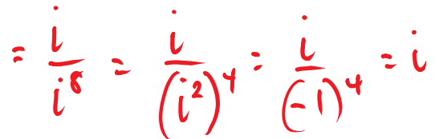6 The value of  is:

A i



B 1

C –1

D –i

E 

[1 mark]

7 

A 3 – i

B –3 – i

C –3 + i

D 3 + i



E 3 + 3i

[1 mark]

8 The solutions to the quadratic equation x2 + 16 = 0 are: 

A 

B ±4

C ±4i



D 

E ±2i

[1 mark]

**Part B**

10 short answer questions

29 marks

Show your working where appropriate.

9 Express the following in the form a+bi: 

[2 mark]

|  |
| --- |
|  |
|  |
|  |
|  |
|  |
|  |
|  |
|  |
|  |

10 A quadratic equation has roots  . Express it in the form

[2 mark]

|  |
| --- |
|  |
|  |
|  |
|  |
|  |
|  |
|  |
|  |
|  |

11 Sketch the graph of y = −sec (x) + 1 for 0 ≤ x ≤ 4π.

[4 marks]

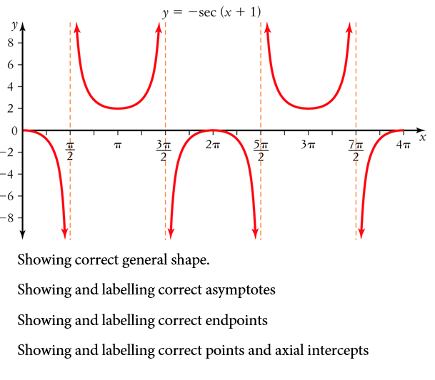



12 Using the Pythagorean identity sin2 (θ) + cos2 (θ) = 1 evaluate cos2  given that sin.

|  |
| --- |
|  |
|  |
|  |
|  |
|  |
|  |

[3 marks]

13 Using a suitable compound angle formula evaluate tan .

|  |
| --- |
|  |
|  |
|  |
|  |

[4 marks]

14 Express cos (60°)  cos (15°) as a sum. DO NOT evaluate.

|  |
| --- |
|  |
|  |
|  |

[1 mark]

15 If w = 2 – 3i, the points A, B, C and D correspond to the vectors  and iw. [5 marks]

a State the coordinates of the points A, B, C and D.

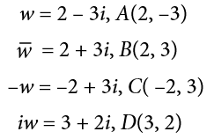



b Plot the points A, B, C and D on an Argand diagram.

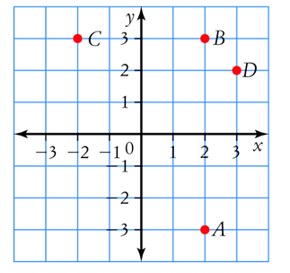



[5 marks]

16 Consider the complex numbers z = –1 +  and w = .

a Find Im(z + w).

|  |
| --- |
|  |
|  |

b Find Re(zw).

|  |
| --- |
|  |
|  |

[4 marks]

17 Solve the equation x2 – 8x + 17 = 0 in the complex plane.



|  |
| --- |
|  |
|  |
|  |
|  |
|  |
|  |
|  |
|  |
|  |

[2 marks]

18 Realise the denominator on , expressing your answer in the form a + bi, where a, b  R.

|  |
| --- |
|  |
|  |

[2 marks]

**Part C**

3 analysis questions

13 marks

Show your working where appropriate.

19 Rewrite the expression sec (x) sin (2x) − sin (x) cos (2x) in terms of sin (x) only.

[3 marks]



|  |
| --- |
|  |
|  |
|  |
|  |
|  |
|  |
|  |
|  |
|  |
|  |
|  |
|  |
|  |
|  |
|  |
|  |
|  |
|  |
|  |
|  |

20 Prove that 1 + tan2 (x) = sec (x) cosec (x) tan (x).

[3 marks]

|  |
| --- |
|  |
|  |
|  |
|  |
|  |
|  |
|  |
|  |
|  |
|  |
|  |
|  |
|  |
|  |
|  |
|  |
|  |
|  |
|  |
|  |

21 Prove each of the following for z = x + yi, where x, y R:

a 

|  |
| --- |
|  |
|  |
|  |
|  |
|  |
|  |
|  |
|  |

b 

|  |
| --- |
|  |
|  |
|  |
|  |

[4,3: 7 marks]

Total marks: 50